Teamcity Config

Build Steps

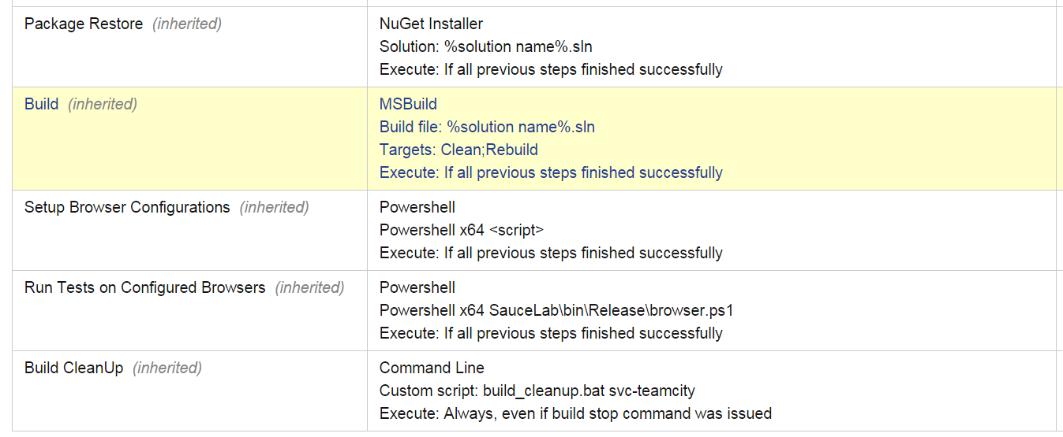

Setup Browser Configurations

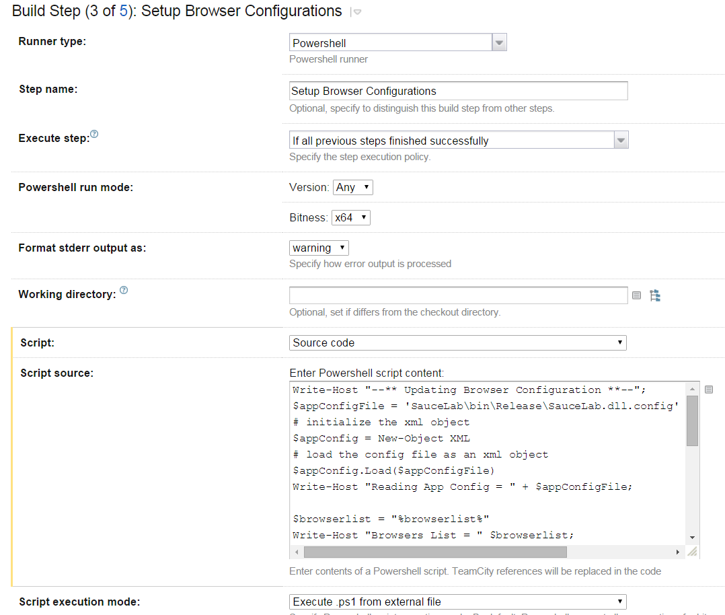

Powershell Script for above step

Write-Host "--** Updating Browser Configuration **--";

$appConfigFile = 'SauceLab\bin\Release\SauceLab.dll.config'

# initialize the xml object

$appConfig = New-Object XML

# load the config file as an xml object

$appConfig.Load($appConfigFile)

Write-Host "Reading App Config = " + $appConfigFile;

$browserlist = "%browserlist%"

Write-Host "Browsers List = " $browserlist;

$appConfig.SelectNodes('//add[@key="BrowserList"]/@value')[0].'#text' = $browserlist

$chrome = "%chrome%"

Write-Host "Chrome Config = " $chrome;

$appConfig.SelectNodes('//add[@key="chrome"]/@value')[0].'#text' = $chrome

$iexplore = "%iexplore%"

Write-Host "IExplorer Config = " $iexplore;

$appConfig.SelectNodes('//add[@key="iexplore"]/@value')[0].'#text' = $iexplore

$firefox = "%firefox%"

Write-Host "FireFox Config = " $firefox;

$appConfig.SelectNodes('//add[@key="firefox"]/@value')[0].'#text' = $firefox

# save the updated config file

$appConfig.Save($appConfigFile)

Write-Host "--** Browser Configuration Complete **--";

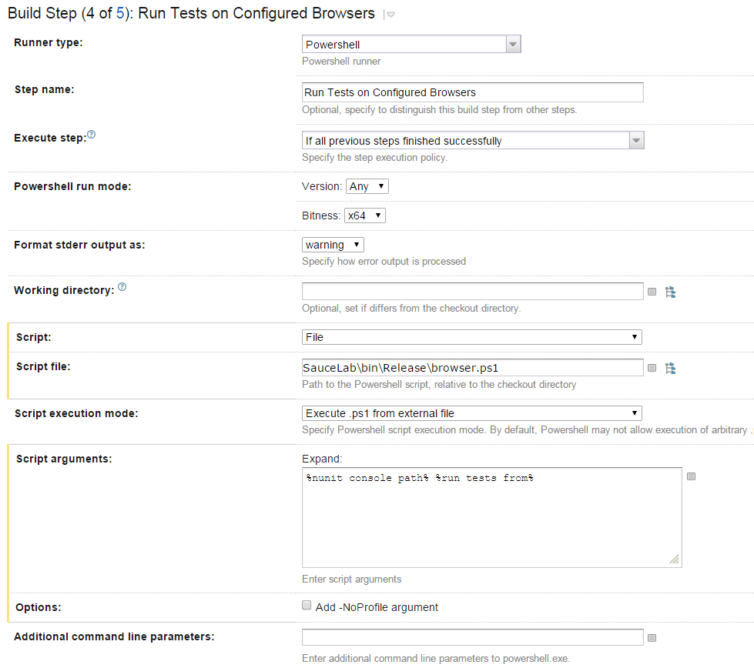

Config parameters

